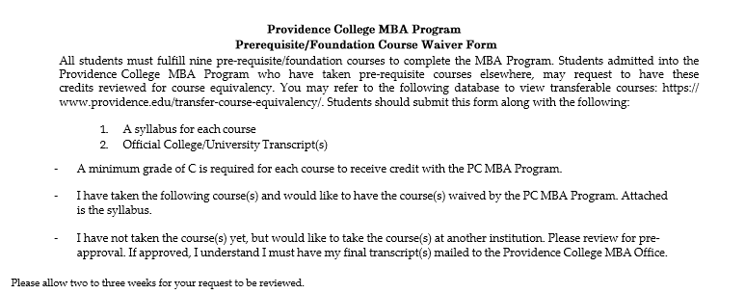
Course  (at other Institution) | Institution Transferring From | Number of credit hours | When taken/ grade received | PC equivalent course | Prerequisite (for office use  only)
Name: _

Phone #: Email:

Student Signature: Date:

Office Use Only:

Pre-Approval Signature: Date:

Post Class Approval Signature: Date:

Date Sent to Dean’s Office: From Dean’s Office to ES:

