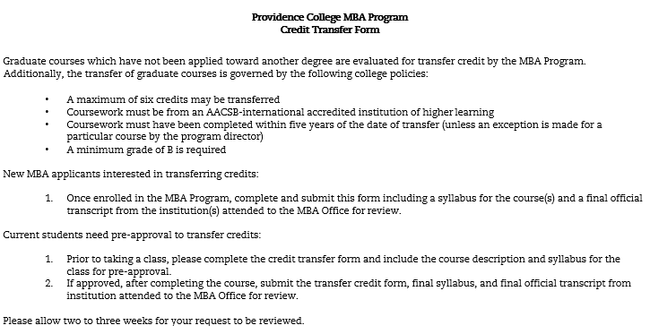
Course  (at other Institution) | Institution Transferring From | Number of credit  hours | When taken/ grade received | PC equivalent course | Core or Prerequisite

Have you previously transferred MBA-level credits into the PC MBA Program? Yes No
If so, how many MBA-level courses have you transferred?*
*Reminder: A Maximum of 6 MBA-level credits (2 MBA courses) may be transferred

Name:

Phone #: Email:

Student Signature: Date:

Current students only:

Banner ID: Term taking course:

Reason for taking course elsewhere:

Official Use:

Pre-Approval Signature: Date:

Post Class Approval Signature: Date:

Date Transcript Received:
Date Sent to Dean’s Office:

Comments __________________________________________________________________________

