MBA 699: Real-World Experience: Business Internships
Learning Agreement Form
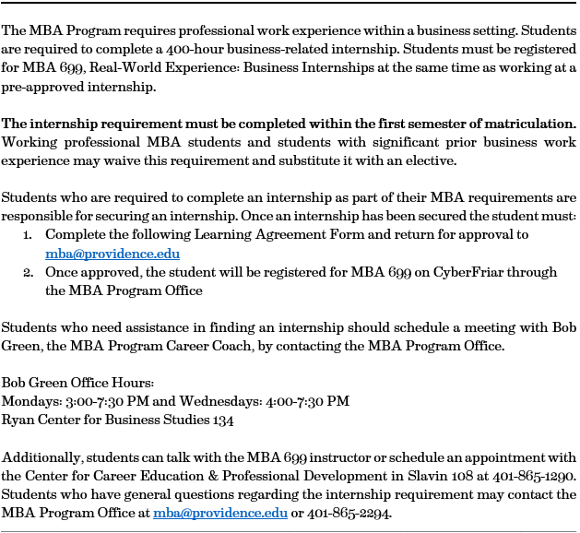

Please fill out the following information.

1. Attach a Copy of Your Internship Offer Letter/Email from Your Employer

2. Students who are both a GA on campus, and are planning to intern on campus, need to submit both GA and internship job descriptions (for on-campus internships only).

3. Student Information
Student Name

Banner ID

Program Entry Term
4. Internship Information
Company Title

Company Address

Company Website
Company Description

5. Position Information
Position Title
Position Description & Job Responsibilities
Position Start Date
Position End Date

Position Hours

Supervisor Name

Supervisor Title

Supervisor Email

6. Develop Learning Objectives & Strategies with Your Supervisor
Learning Objectives: These are statements that describe what you expect to learn. Learning objectives might include your intention to expand/develop knowledge in a specific area, improve/develop specific skills/competencies, or develop personal insights regarding your values or attitudes. It is recommended that you list at least 3-4 learning objectives.
Learning Strategies: These are statements that describe how you intend to achieve your objectives. Examples of how you might achieve your learning objectives include: specific tasks on a project, training, seeking feedback and mentors, attending meetings, research, MBA course work, etc. Please list at least 1 learning strategy for each learning objective specified.

By signing this form, the hiring company, internship supervisor, MBA 699 course instructor, and the MBA student all agree to the internship responsibilities and expectations listed above, as well as to the requirements of the course as outlined in the syllabus.

Required Signatures | Date
Student:

Internship Supervisor:

Faculty Supervisor:

CONTACT INFORMATION
Providence College MBA Program
Ryan Center for Business Studies 135
1 Cunningham Square
Providence, RI 02918

401.865.2294
mba@providence.edu

Office Use Only
Decision: .Staff Initials: Date Registered on CyberFriar:

